REGISTRATION FORM for CharACTer Curtain Calls
Please Print
___________________________________Student (Last Name, First Name)

___________________________________Legal Guardian (Last Name, First Name)
___________________________________Mailing Address (Number, Street Name)
___________________________________ (City, Postal Code)
___________________________________Email Address
___________________________________Home Phone Cell Phone
_____________ AGE as of Dec. 31, 2016 (Minimum age 8)
Date of Birth ________________________
GRADE ______

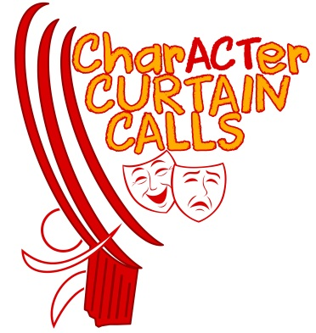
Shirt Size? Circle one.
S-Youth M-Youth L-Youth
XL-Youth
S-Adult M-Adult L-Adult
XL-Adult
Allergies: ___________________________________

Other Health Concerns:
___________________________________
E-mail: charactercurtaincalls@gmail.com

Sessions will run most Tuesday nights from 6:00-7:15 p.m. at the Elgin Mall (in the unit West of the library location.) Sessions will begin October 4 and will continue until May 2, except during school holidays. Our May performance dates are Friday, May 5 (evening) and Saturday, May 6 (afternoon and evening). The evening of May 4 will be the dress rehearsal. All May 3-6 events will take place at the Port Stanley Festival Theatre.
Sessions Include: •Acting games •Improvisation •Musical theatre •Characterization •Year-end public performances

Registration Fee $275.00
A $50 deposit is due with the registration form. The balance of $225 is due by September 20.
Cheque, payable to Character Curtain Calls ____ Cash ____
NSF Cheques will incur a $25.00 fee. No refunds will be made once the 2nd session has started.

Our mission is to provide a fun and encouraging arts environment for children and youth to explore and develop drama activities and/or events. CharACTer Curtain Calls will promote a safe environment by preventing harm to those in our care. We have a zero tolerance for harassment and bullying. 1/2
RELEASE FORM
This release form must be signed and submitted to Character Curtain Calls before this registration can be processed and confirmed. I am the legal parent or legal guardian of:
_______________________________________
(the “Student”), who is under 18 years of age, and desire that the Student participate in the full programs and activities (the “Activities”) of Character Curtain Calls (“CCC”).
I acknowledge that I must advise CCC in writing if the Student is not physically able to participate fully in the Activities. I also acknowledge that there are risks in participating in the Activities. I agree that, having taken such precautions as in its discretion are deemed advisable, CCC will not be held responsible for any injury, sickness or accident to the Student or for any loss or damage to personal property resulting from the Student participating in the Activities. I authorize the Theatre to secure medical care for the Student. If for any reason the Student requires medical attention beyond any first aid furnished by or on behalf of CCC, I agree to be responsible for any expenses incurred. I agree to indemnify CCC, its officers, directors, agents, and volunteers and save them harmless from and with respect to all suits, actions, and prosecutions by reason of any Activity carried out by the Student, whether on or off CCC’s rehearsal space. I also agree to indemnify and save harmless 417 Wellington Street Property Holdings Inc. and the Port Stanley Festival Theatre from all losses, claims, demands, costs, damages, and suits of whatever nature or kind which may arise as a result of the use by CCC.
I understand that all fees are due with the submission of this Release form and attached Registration form. After the second session begins, no refunds will be issued by CCC. There are no refunds for missed program sessions or for sessions cancelled due to severe weather.
CCC reserves the right to cancel any program for which there are insufficient paid registrations. Refunds would then be issued.
For the safety of all children with allergies, we require that no nut products be brought to any of our rehearsal/show locations.
For the safety and health of participants and volunteers, we request that no perfume is to be worn at any of our rehearsals/show locations.
Canada’s Anti-Spam Legislation (CASL) came into effect on July 1, 2014. In order for CCC to send you program information and other relevant communication, we seek your expressed consent by signing the release below. You always have the option to withdraw your consent at any time.
Photography and Video Release: I consent to the use of the likeness (including still photographs and videos) of the Student in connection with Character Curtain Calls and I understand that these photos/videos may be used for archival and promotional purposes. CCC does not use the full identity of the performers in their own promotional work, but photos taken by the media may potentially list the names of the actors in the photo/video.
I expressly release CCC, its officers, directors, agents, volunteers, licensees and assigns from and against any all claims for invasion of privacy, defamation, infringement of copyright or any other cause of action that may arise out of such use.
I hereby irrevocably release CCC from any and all claims for libel and invasion of privacy in connection with the foregoing.
I, the undersigned, have read the above and agree to its terms.
_______________________________________ Printed name of parent or legal guardian

_______________________________________ Signature Date

2/2

