REGISTRATION FORM

Please Print
___________________________________Participant (Last Name, First Name)

___________________________________Legal Guardian (Last Name, First Name)
___________________________________Mailing Address (Number, Street Name)
___________________________________ (City, Postal Code)
___________________________________Email Address
________________/__________________Home Phone Cell Phone
_______ Age as of Dec. 31, 2022
Date of Birth ________________________
GRADE: __ School: __________________

CharACTer Curtain Calls’ Theatre Programs for Young People: (Please select one)
Grades 1-3 (As of September, 2022)
Monday nights from 6:30-7:15 Oct. 17- March $250
Grades 4-6 (As of September, 2022)
Tuesdays from 6:00-8:00 Oct. 4- late March $350
Grades 7 and up (As of September, 2022)
Thursdays from 6:00-8:00 Oct. 13- April $350
There are no sessions during the weeks of December 12, 19, 26, January 2 and March 13. Depending on theatre availability, season-ending public performances for the three groups are planned for March and April. Performance dates will be finalized before the sessions begin.

www.charactercurtaincalls.org charactercurtaincalls@gmail.com
The full registration fee is due when submitting this form and attached Release Form. Please send these documents electronically to charactercurtaincalls@gmail.com. An e-transfer to charactercurtaincalls@gmail.com is preferred, but a cheque (payable to Character Curtain Calls) is also accepted. If paying by cheque, please register electronically but mail your cheque to 15 St Catharine Street, Suite 303, St. Thomas, N5P 2V7. Thank You

Payment Options:
e-transfer ____
cheque ___

Allergies/Health Concerns:
_________________________________
www.charactercurtaincalls.org

Please kindly notify us of any allergies or health concerns.
All sessions take place at 15 St Catharine Street, Suite 303 in St. Thomas.
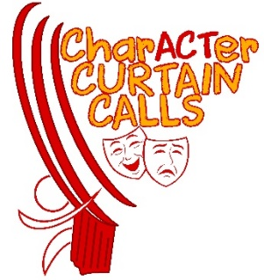
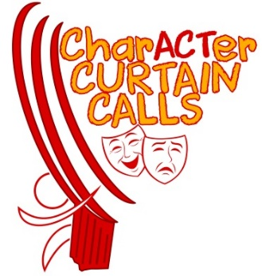

RELEASE FORM
This release form must be signed and submitted to Character Curtain Calls before this registration can be processed and confirmed. I am the legal parent or legal guardian of:
_______________________________________(the “Participant”), who is under 18 years of age, and desire that the Participant engages in the full programs and activities (the “Activities”) of Character Curtain Calls (“CCCalls”). I acknowledge that I must advise CCCalls in writing if the Participant is not physically able to participate fully in the Activities. I also acknowledge that there are risks in participating in the Activities. I agree that, having taken such precautions as in its discretion are deemed advisable, CCCalls will not be held responsible for any injury, sickness or accident to the Participant or for any loss or damage to personal property resulting from the Participant engaging in the Activities. I authorize CCCalls to secure medical care for the Participant. If for any reason the Participant requires medical attention beyond any first aid furnished by or on behalf of CCCalls, I agree to be responsible for any expenses incurred. I agree to indemnify CCCalls, its officers, directors, agents, and volunteers and save them harmless from and with respect to all suits, actions, and prosecutions by reason of any Activity carried out by the Participant, whether on or off CCCalls’s rehearsal space. I also agree to indemnify and save harmless rehearsal and performance venues from all losses, claims, demands, costs, damages, and suits of whatever nature or kind which may arise as a result of the use by CCCalls.
I understand that the full registration fee is due with the submission of this Release form and attached Registration form. The registration is not considered complete unless accompanied by the required fee. Please ensure that you have no conflicts with the stated dates and times.
CANCELLATIONS/REFUNDS: CCCalls reserves the right to cancel any program for which there are insufficient paid registrations. Full refunds would then be issued. There are no refunds for missed program sessions, by participant, or for sessions cancelled due to severe weather.
For cancellations by registrant: Full Refund (less e-transfer charge): By August 1, 2022. Full Refund less $25: Between August 2, 2022 and August 31, 2022. Full Refund less $50: Within 4 weeks prior to first session. No Refund: As of the first session of the program, regardless of reason.
COVID-19 Protocols: CCCalls fully complies with any public health directives. Masks may be needed at certain times of the season, due to the presence of communicable illnesses, but we will give advance notice of such a requirement.
For the safety and health of participants and volunteers, we request that no perfume be worn at any of our rehearsals/show locations and that no nut products are brought to any rehearsal/show location.
Casting decisions for the season-ending production are made solely by the Directors of CCCalls.
CONDUCT: It is expected that participants exhibit proper behaviour and participate under the direction of the leadership. If inappropriate behaviour continues after speaking to the child and parents, the child may be asked to withdraw from the program, with no refund.
When attending sessions, participants are expected to: Come to sessions/rehearsals prepared and on time, be respectful of the directors and fellow members, learn their part(s), and perform to the best of their abilities. It is also expected that parents will help their child memorize their lines at home once roles have been assigned.
Canada’s Anti-Spam Legislation (CASL) came into effect on July 1, 2014. In order for CCCalls to send you program information and other relevant communication, we seek your expressed consent by signing the release below. You always have the option to withdraw your consent at any time. Photography and Video Release: I consent to the use of the likeness (including still photographs and videos) of the Participant in connection with CCCalls and I understand that these photos/videos may be used for archival and promotional purposes. CCCalls does not use the full identity of the performers in their own website promotional work, but full names are listed in the performance playbills. Photos taken by the media may potentially list the names of the actors in the photo/video.
I expressly release CCCalls, its officers, directors, agents, volunteers, licensees and assigns from and against any all claims for invasion of privacy, defamation, infringement of copyright or any other cause of action that may arise out of such use. I hereby irrevocably release CCCalls from any and all claims for libel and invasion of privacy in connection with the foregoing.
I, the undersigned, have read the above and the information contained on the Registration form and agree to its terms.

______________________________________ Printed name of parent or legal guardian

___________________________ ________________
Signature Date
Thank you for your support of CCCalls!

